**Word Basics Lesson Plan**

**PREP WORK:**

* Read handouts on Word Basics. Each location uses a slightly different version of word. Make sure you are working with the correct version.
* Get to library early to test for technology failures
* Make you have enough copies of the handouts and the feedback forms

***The library will print handouts for us.

**OBJECTIVES:**

* Understand what Microsoft Word is
* Navigate the ribbon menu system
* Type text in a document
* Inserting photos/clip art into a document
* Format text
* Use the spell and grammar check feature
* Use the undo and redo button
* Copy, paste, cut and delete text
* Find and use the Microsoft Word help feature
* Save documents

**Before class:** Record attendance, make sure there are enough handouts for class, make sure you have feedback forms for the end of the course, check computers to make sure they are on and ready to use.

**LESSON OUTLINE:**

**Introduction**

* Introduce instructor, students, goals for the class
* Let students know they can take phone calls, but remind them to put phones on vibrate and answer them outside of class
* Inform students, they can leave for the restroom anytime—No need to ask
* Show/tell the class timeline to students
* State/show order in which class will happen. Explain scope of class. If you have a white board, write down briefly what will happen during the course.
* **Icebreaker Question:** What is your experience with Microsoft word?

**I. Overview of Word**

* What is MS Word?
* Software used to create and print text documents
* Changes can be easily made such as correcting spelling, adding, deleting, formatting and relocating text
* Document can be printed quickly and accurately saved for later modifications
* **Activity:** Open Microsoft Word. Directions for opening Microsoft Word appear on page 3 of the students’ packet. Tell students to read page 3 and open word. Help those who are struggling, and/or invite other students in the class to help those who are struggling to open word.

**II.** **The Ribbon Menu System**

*Note: Sometimes inviting students to click through each tab as the tab is being discussed can be helpful.*

* **Tabbed ribbon menu system:** Allows you tonavigate through Word and access the various Word commands. If you have used previous versions of Word, the Ribbon system replaces the traditional menus.
* **File:** In Microsoft Office 2007, there was something called the Microsoft Office Button in the top left hand corner. In Microsoft Office 2013, this has been replaced with a tab in the ribbon labeled “file,” when you left click on this tab, a new window appears. From this menu you can perform the same functions as the Microsoft Office Button menu, such as: create a new document, open existing files, save files in a variety of ways, and print. Don’t worry your document isn’t gone! Just click the left arrow at the top to get back to your document.
* **Home:**  The most used features are in the Home tab, such as Copy, Cut and Paste. The HOME Tab Toolbar offers options that can change the font, size, color, alignment, organization and style of the text in the document.
* **The Ruler:** This feature allows you to change the dimensions of your text document
* **Insert:** This feature allows you to include tables, images, shapes, and other non-textual items into your word document.
* **Review:** This tool contains features that will help you edit the document, such as spell check. Be careful—sometimes the spell check feature cannot tell the difference between write and right.

**III. The Keyboard:**

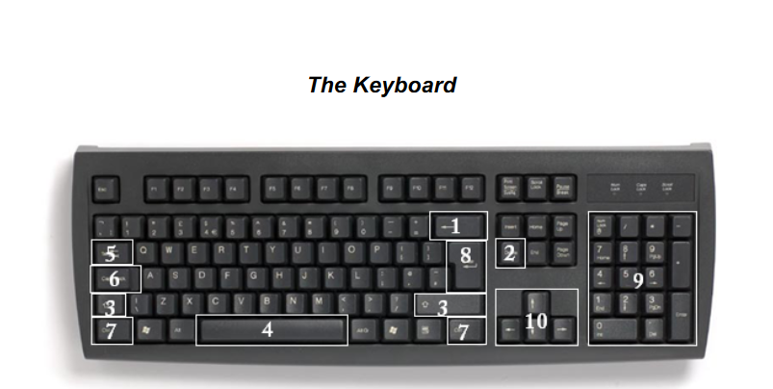

* In order to use MS Word effectively, you must input commands using both the mouse and the keyboard. The above image of a keyboard may closely resemble (if it is not identical to) the keyboard in front of you; learning just a few certain keys will help to improve your efficiency in typing as well as present you with more options within the program. The following is a list of commonly used keys that have special functions in MS Word (key functions can change depending on which program you are using):
* If a student wants to practice typing they might consider trying typing club: <https://www.typingclub.com/>

**IV. Activity: Creating a Flier Activity (30 minutes at least)**

* See flier activity and student sample. Each library has their own set of directions because each library has their own version of word.

**V.** **Undo and Redo Buttons**

* The Undo and Redo Buttons can be found on the top left hand side of word next to the save button. These buttons allow you to redo and undo the most recent changes you’ve made to your document.
* **Activity:** I want you to try and undo the last thing you completed in your flier using the Undo button. Now, I want to hit the redo button to bring what you did back to the flier.

**VI. Copy, Paste, and Cut**

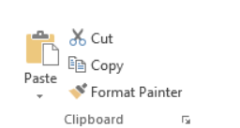

* **Cut:** represented by scissors. This feature allows the user to highlight and delete information in their document
* **Copy:** command is represented by the icon with two documents. This feature will not alter your original selection at all, as it simply makes a copy of the selection without changing or deleting it in any way.
* **Paste:** represented by a clip board and a document. The paste feature is used after you have copied something in your document. You can paste replicas of information you have copied into new locations.
* **Activity:** Try to copy the image you used in your flier. Paste this clip art onto a new page in the same word document.

Microsoft Word Basics Flier Activity

**Purpose:** The purpose of this activity is to practice typing and formatting in word. You will also practice inserting images into word. Our goal is for you to become comfortable with the basics of using the program, saving your file, and using features like spell check to appropriately review your work.

**Task:** The public library is going to have a party to celebrate their 100th anniversary of service to the community. For this activity, I would like you to use your new found skills with Word to create a flier to advertise this event. The flier must include the following elements:

1) An event title in at least 15 point font. Make sure the title is in the center of the page. You may use any font you want, but it must be a font that is clear to read. (See pg. 6 of your packet for help)

2) A clip art picture to represent the event (See pg. 12 of your packet for help)

3) Tell us the WHAT, WHEN, WHERE, WHY of the event. For example, What will happen at the event? Will librarians tell stories to children? Will authors read their books? What time will this event start and end?

4) You may look at the flier on the back of this sheet of paper as an example.

5) Use the spell check feature under review to make sure there are no mistakes. (See pg. pg 10 of your packet for help)

6) When you are finished, save your file. You will want to make a file name that you will remember. For example, you might use your last name + what the document is. Ex) KehoeLibraryFlier.

7) Be creative and clear.

8)You are encouraged to ask me or your neighbor for help!

C:\Program Files (x86)\Microsoft Office\MEDIA\CAGCAT10\j0216588.wmf

**100 Year Celebration!**

**What:** The Chapel Hill Library is celebrating 100 years of bringing free books and resources to the local community. Come out and celebrate with us we as read stories to children, invite local authors to read their books, and eat cake.

**When:** 8am to 5pm on July 6th, 2001

**Where:** Chapel Hill Public Library

**Why:** We love public libraries!

