Internet Basics
Lesson Plan
Fall 2018
CWS
Internet Basics
Estimated Lesson Time: 90 minutes

PREP WORK:
- Read handouts on Internet Basics
- Get to the library early to test for technology failures
- Make sure you have enough copies of the handouts and the feedback forms
- Make sure you have copies of the instructor evaluation form
***The library will print handouts for us.
OBJECTIVES:
- Understand basic internet vocabulary
- Use and understand basic browser functions
- Conduct a search to find information online
- Know how to stay safe online

LESSON OUTLINE
- Introduction:

- Introduce instructor, students, goals for the class
- Let students know they can take phone calls, but remind them to put phones on vibrate and answer them outside of class.
- Inform students they can leave for the restroom anytime—No need to ask.
- Show/tell the class timeline to students
- Icebreaker Question: What is your experience with the Internet? What is the internet used for?

- What is the Internet?
Test for knowledge: What is the internet? What is the internet used for?
One of many different answers you could use or receive:
The Web, also known as the World Wide Web (WWW), is essentially a collection of an uncountable number of pages of information displayed on the Internet. It is an information-sharing tool that is growing at an unbelievable rate. According to a Google study, there are over a trillion unique web pages, and over 4.5 million new websites are registered each month. You can view this information with the help of a “web browser”—a window that allows you to view online content (e.g., Internet Explorer, Mozilla Firefox, Safari, and Google Chrome). Because there is so much information on the Internet, and so many individual sites and pages, it would be nearly impossible to find what you were looking for by just “browsing” or flipping through sites, not only because of the sheer size of the collection, but also because you wouldn’t know what address to go to! To deal with this, we use a web browser to access a search engine which allows us to search for a particular topic, word, or phrase. The Internet is a communications network that connects computers from all around the world. To reach different websites, we use search engines like Google or Bing to search for websites about a particular topic, word, or phrase. Just like you might use the library catalog to find a book or the phone book to find a business, search engines organize information and make it accessible for Internet users. If you can think of a topic, there is probably a website about it.
- Getting Online:
To get online, we need to use a web browser, like Google Chrome, Duck, Duck Go, or Firefox. A web browser is a program that allows users to view pages online.
Locate a web browser icon on the desktop. (There should be a picture of the icon in the student packet.)
Left click on the web browser icon twice to open it. If you cannot find the web browser icon, you can always locate it in the start menu in the bottom left hand side of your screen.
Simply type in the name of the web browser you would like to use in the search bar. For this lesson, we are going to use Google Chrome, but students are welcome to choose a web browser they feel comfortable with.
Everyone should open a web browser before going on to talk about web terms.

- Web Terms: Creating a Vocabulary

There are a number of terms that will help us navigate the web faster.

*Teaching Tip: As you go over these terms, have a webpage pulled up. Use the mouse and point to each part of the website so that students know what you are talking about. Encourage students to do the same. For example, if you are talking about the back button, hit the back button and let the students practice hitting the back button just to experience what it does. You can also go through activity one on the handout.

- Browser: A program that allows us to view the internet

- Web Address/URL: Like a house address for a webpage. Displayed in the browser’s address bar.

- Website: A collection of webpages

- Link: Text or image that "links” or connects us to another webpage when we click on it

- Search Engine: A website used to search for information on other websites

- Internet/World Wide Web: A network of interconnected computers from around the world

- Back Button: Takes you back to the last page you were on

- Forward Button: Takes you forward one page at a time

- Refresh Button: Reloads the page with any changes since it first loaded. Use if the page won’t load properly.

- Home Button: Returns you to the first page you see when you open the browser

- Menu: Shows options for the browser, such as settings, printing, browsing history.

Activity 1: See Student Handout for complete instructions.

Ask students to use the back button, the forward button, the refresh button, the home button and the menu button.

- Searching for Information
Now that we have practiced the basics of navigating the web, you’re ready to start performing your own searches. In pairs, practice answering the following questions online:
- Your friend calls to say they have a flat tire on the side of the highway. They have all the items they need to change the tire, but they have never changed a flat tire before. They do not have a smart phone. They called you because they want you to look up on google how to change a flat tire and read them the information. Your job is to find a website to help your friend.
- You are interested in attending more events at the public library. Using google, search for your library’s event calendar. Find one event you might be interested in attending.
- You’ve just won a trip to Paris for checking out your one millionth book from the library (It could happen! Maybe?!). You need to know what the weather will be like in Paris this week. Use google to figure out the answer.
- Brainstorm with your partner a list of other useful things that you could look up online. Write down a few of these answers to share with the class.

- Handling Multiple Searches at Once:
Sometimes when we are searching online for information, we are comparing information from two different places. For example, we might want to know what the price of a computer is on Amazon versus the price of a computer at BestBuy. We can use the internet to navigate to multiple websites and keep the information open on different tabs.
Tabs are different pages of the internet that you are switching between while you are using the web.
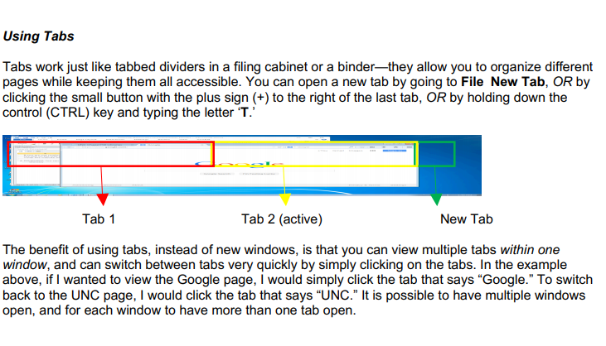
Practice: Using google chrome, pull up two different tabs. On one tab, navigate to one library’s calendar (such as Chapel Hill), on another tab navigate to another library’s calendar (such as Carrboro).
Ask students to click between tabs to compare the two calendars.
Question to ask the class: Why would this knowledge be useful?

- Information We can Encounter and Staying Safe Online:

- Viruses are malicious programs that are loaded onto your computer without your knowledge. They can destroy or delete everything on your hard drive, such as your files and folders, or extract personal information. Your computer can become infected when you download pictures and files from the web or email messages, so avoid downloading files from the Internet unless you are sure it is safe. If you receive an e-mail from a friend with an attachment and it seems strange, verify that they intended to send you the attachment before you open it.

- With millions, upon millions of websites, obviously not all the information online can be correct. But there are signals within web pages that inform us whether or not information is reliable.

Here are a few examples:

.edu - a web address ending in .edu is a website created by an educational institution

.org - a web address ending in .org is a website created by an organization. Often non-profits use .org.

.com - many websites, including businesses, use .com. Anyone can create a .com website. Sometimes the information is reliable. Sometimes the information has a bias. (For example, Amazon.com wants to sell us products)

- Closing:
- Review the information covered in the lesson.
- Ask if there are any questions about the material.
- Hand out feedback forms to students.
- Floater and Instructor fill out self-evaluation forms.
- Make sure you know how many students attended class and write down the number on the self-evaluation forms.
- Tell students what the next class will cover. Calendar can be found on the CWS website: http://cws.web.unc.edu/schedule/

Internet Basics Activities
Purpose: Each of these activities is designed to teach you the basics of navigating the Internet. By the end practicing these activities, you should know how to navigate between web pages, understand basic web navigation terms (refresh, home, back, forward, URL), and you should be able to perform a google search for information.
Activity One:
- Using Navigation Tools Online
- Open your web browser
- Type the following website into your web browser: https://chapelhillpubliclibrary.org/
- Hit the back button to take you back to the home page
- Hit forward button to take you back to the library website
- Hit the refresh button to reload the page.
- Hit the home button to return to the home page.
Activity Two:
- Navigation Practice
- Click on minimize button to make the webpage return to the tool bar.
- Click on the maximize button to make the webpage fill the whole computer screen.
- Click on the new tab button to create a new tab.
- Click on the X to close out the web page.
Activity Three:
- Searching for Information:
In pairs, practice answering the following questions online:
- Your friend calls on the phone and says that they are experiencing a flat tire on the side of the highway. They have all the items they need to change the tire, but they have never changed a flat tire before. They do not have a smart phone, and they have called you because they would like you to look up on google how to change a flat tire and read them the information. Your job is to find a website to help your friend.
- You are interested in attending more events at the public library. Using google, search for your library’s event calendar.
- You’ve just won a trip to Paris for checking out your one millionth book from the library (It could happen! Maybe?!). You need to know what the weather will be like in Paris this week. Use google to figure out the answer.
- Brainstorm with your partner a list of other useful things that you could look up online. Write down a few of these answers to share with the class.

Instructors: Do you have suggestions that might make this lesson better? Do you want to create your own online basics lesson plan? Let us know!

