Doing More with Word Lesson Plan
PREP WORK:
- Read handouts on Doing More with Word. Each location uses a slightly different version of word. Make sure you are working with the correct version.
- Get to library early to test for technology failures
- Make you have enough copies of the handouts and the feedback forms
- Download the Sample formatting Paper from Microsoft Teams
***The library will print handouts for us.
OBJECTIVES:
- Review Ribbon Menu System
- Create Bulleted and Numbered Lists
- Create tables
- Adding Footing and headers
- Insert page numbers
- Modify line spacing
- Insert a table of contents
- Insert boarders

Before class: Record attendance, make sure there are enough handouts for class, make sure you have feedback forms for the end of the course, check computers to make sure they are on and ready to use.
LESSON OUTLINE:
I . Introduction
- Introduce instructor, students, goals for the class
- Let students know they can take phone calls, but remind that to put phones on vibrate and answer them outside of class
- Inform students, they can leave for the restroom anytime—No need to ask
- Show/tell the class timeline to students
- State/show order in which class will happen. Explain scope of class. If you have a white board, write down briefly what will happen during the course.
- Icebreaker Question: How are you currently using word? What documents are you already creating?

II. Review Basic Features of Word/Ribbon Menu System
**Note: I can be a good idea to give the students a chance to explain what these tabs and features all mean. This will allow you to see where the class is at in terms knowledge.
- Tabbed Ribbon menu system: Allows you to navigate through Word and access the various Word commands. If you have used previous versions of Word, the Ribbon system replaces the traditional menus.

- File: In Microsoft Office 2007, there was something called the Microsoft Office Button in the top left hand corner. In Microsoft Office 2013, this has been replaced with a tab in the Ribbon labeled File, when you left click on this tab, a new window appears. From this menu you can perform the same functions as were found under the Microsoft Office Button menu, such as: create a new document, open existing files, save files in a variety of ways, and print. Don’t worry your document isn’t gone! Just click the left arrow at the top to get back to your document.

- Home: Most used features in the Home tab, such as Copy, Cut and Paste. The HOME Tab Toolbar offers options that can change the font, size, color, alignment, organization and style of the text in the document.

- The Ruler: This feature allows you to change the dimensions of your text document

- Insert: This feature allows you to include tables, images, shapes and other non-textual items into your word document.

- Review: This tool contains features that will help you edit the document, such as spell check. Be careful—sometimes the spell check feature cannot tell the difference between write and right.
III. Bullets
- Bullets are a way of calling out lists in your document.
- Ask students where they might have seen bulleted or numbered lists?
    - Resumes
    - Recipes
    - Stats (like Olympic listings)
- Bullets are used in unordered lists. So when you list skills in a resume, you aren’t saying “I’m first good at this, then I’m second good at that”. You’re making a list of things that you do really well in no particular order.

- Numbered lists are a little more straightforward. They are lists that show that there is an exact sequence to the list (e.g. Who finished the race in what order, or what you should do first when you are building a chair from IKEA).

- Activity: Create a list of grocery items using bullet points. Create a list of instructions to check out a library book using numbers. Direct students to page 6 of their packet for further instructions.

Tip!: Students may click on the drop-down arrow next to the bullets button. This will give them bullet shape options. Options are the best!
.
IV. Tables

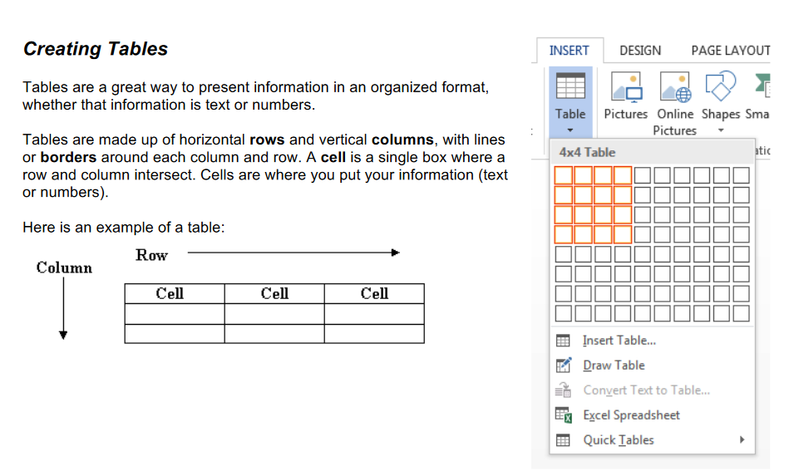
When you need to organize text information or numerical data, a table can be useful.

Activity: Create a table that organizes the information in your grocery list. Example,

Activity : Organize your shopping list in a table. The first line of your table should tell your reader what the information in that row will be. Put this first line in bold (See page 6 for help).
Example:

Fruit | Vegetables | Dry Goods | Dairy
Apples | Spinach | Bread | Eggs
Bananas | Sweet Potato | Pasta | Almond Milk
Mangos | Broccoli | Black Beans | Cheese

V. Formatting a Paper
These next couple of concepts are paired with the Formatting a Paper activity. Invite students to
Modifying Line Spacing
- Line spacing in Word refers to the amount of space between lines of text. The default in Word 2010 is 1.15 spacing, which leaves a little bit more space than single-spacing, or what you would find in a normal book. Single spacing is generally easy for the eye to read. There may be times, however, when you want to change this spacing. One common option is to double-space text.

- Double-spacing is especially useful if someone else is proofreading your document. It allows for more room to write comments on the page.

To change the line spacing:

1. Select text you want to format by highlighting it.
2. On the Home tab, click on the Line Spacing button in the Paragraph group.
3. Choose the spacing you want from the menu that appears.

Activity: Change the line spacing to double spaced in the sample paragraph.

Adding Headers and Footers

Headers and footers are sections at the top and bottom of a page, respectively, which contain information like page numbers, dates, or authors. The information in headers and footers is usually the same for all pages of a document (for example, the author’s name might appear in the upper right-hand corner of every page).

To insert a header or footer:
- Select the INSERT tab.

- Click on the Header, Footer, or Page Number button from the Header & Footer group.

- Click on the style you want from the menu that appears.

- The main body of text will be grayed out and there will be boxes with dotted lines around it at the top and bottom of the page. The Header & Footer Tools tab will also appear.

- Type your text into the boxes with the dotted lines.

- Click “Close Header and Footer” on the menu when you are finished.

You can use the Header & Footer Tools tab to help you enter information and format your headers and footers.

Activity: Insert a header in the Sample Paragraph.
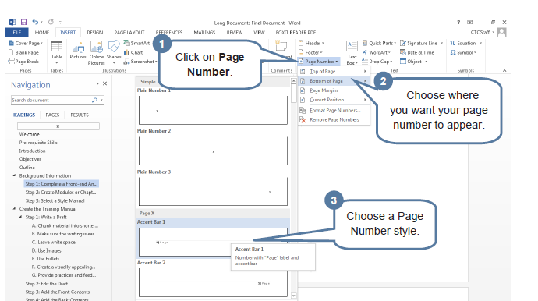
Adding Page Numbers
Activity: Insert a page number in the top right hand corner of the header in your sample paragraph. Then type your name in the top left hand corner of the header.
Creating a Table of Contents
Imagine this Sample Paragraph is the start to a larger paper. This means we will likely want a table of contents that will allow us to organize our information. To create a table of contents, follow these steps:
- Make “Toward a Recovery of Nineteenth Century Farming Handbooks” the title of your paper by putting it on the first line and centering it.

- Select the title “Toward a Recovery of Nineteenth Century Farming Handbooks.”
- Click on Heading 1 on the Home Tab
- Click on the references tab.
- Click on the table of contents
- Choose a table of contents style
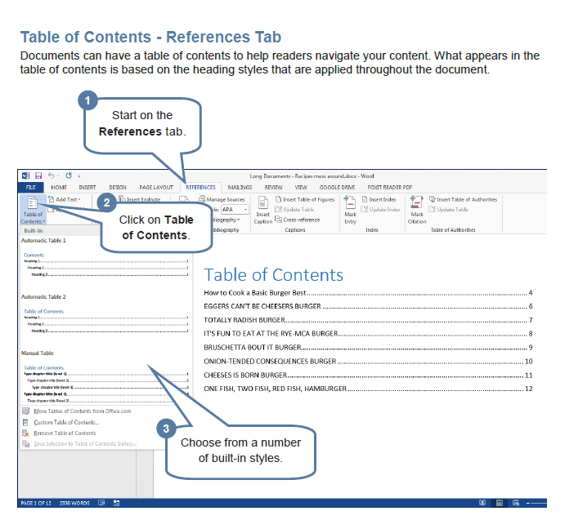

Where to Get More Help

- Every library has both internet and Word on their computers. Please practice at a location that is convenient for you!
- Word tutorials at gcflearnfree.org.

- Go to gcflearnfree.org.
- Click on the Microsoft Office tile.
- Click on Word 2013.
- Assign the tutorials on topics you covered today

Conclusion:
- Ask students what else they would like to learn about word
- Review the topics that have been covered
- Hand out feedback forms
- Invite students to the next class/Show students the schedule

Doing More with Word Activity Sheet

1) Numbers and Bullets
Create a grocery list of 5 items using bullets (see page 6 for help)
Example:
- Eggs
- Butter
- Bread
- Broccoli
- Apples
Create a list of instructions to check out a library book using numbers (see page 6 for help)
Example:
1. Find a book you want to read
2. Take the book to the front desk
3. Give the librarian your library card

2) Creating Tables
Organize your shopping list in a table. The first line of your table should tell your reader what the information in that row will be. Put this first line in bold (See page 6 for help).
Example:

Fruit | Vegetables | Dry Goods | Dairy
Apples | Spinach | Bread | Eggs
Bananas | Sweet Potato | Pasta | Almond Milk
Mangos | Broccoli | Black Beans | Cheese

3) Formatting a Paper

The instructor has given each of you a Sample paragraph to format in word. As a class, we are going to put the paragraph into what is called MLA format. This is the standard format for papers written in an English class. The purpose of this exercise is to practice working with line spacing, headers, inserting page numbers, using the tab key, and changing the font.
1. Change the font from 11 point to 12 point.
2. Change the font to Times New Roman
3. Change the line spacing to double spaced (see page 6)
4. Insert a header (See page 9)
5. Insert a page number in the top right hand corner of the header. (see page 9)
6. Type your name in the top left hand corner of the header.
7. Find the title in the first line: “Toward a Recovery of Nineteenth Century Farming Handbooks” Use this as the title and center this title above this paragraph.
8. Create a paragraph indention using the tab button.
9. Create a table of contents

