Keyboard and Mouse Practice
Lesson Plan
Summer 2019
CWS
Keyboard and Mouse Practice: Open Lab
Estimated Lesson Time: 90 minutes
PREP WORK:
- Read through this lesson plan
- Test the games in this lesson to make sure they all work.
- Get to library early to test for technology failures
- Pull up the mouse/keyboard games on the computers:
***The library will print handouts for us.
OBJECTIVES:
- Use and understand the different functions of the mouse (Left Click, Right Click, ect.)
- Understand the basics of a keyboard usage
- Use home row keys

OPEN LAB GOALS:

The purpose of this open lab is to let students practice and ask questions about using the mouse and keyboard. Most of this class will rely on independent activities where students are practicing these objectives, and the instructors/floaters travel the room working with students one-on-one.
LESSON OUTLINE
- Introduction:
- Introduce instructor, students, goals for the class
- Let students know they can take phone calls, but remind that to put phones on vibrate and answer them outside of class
- Inform students, they can leave for the restroom anytime—No need to ask
- Show/tell the class timeline/objectives to students
- Icebreaker Question: Why did you choose to come to a mouse and keyboard practice class? What do you hope to learn today?
- How to use the mouse:
One of the most difficult things to learn when first beginning to use a computer, is how to use the mouse. It takes coordination, precision, and patience. Fortunately, the more you practice, the easier it will become.

.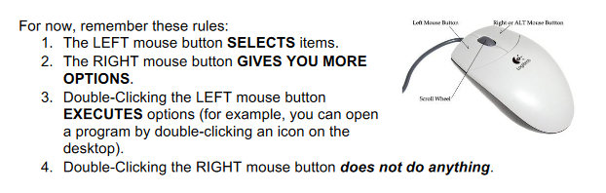
As a class, practice each of these mouse commands.
Activities: Let students decide which mouse games they could like to try.
- Mousing Around: The first activity is familiar to returning students. I would direct returning students to another activity, but if you have a student who is brand new to the class, this is a good instruction tool for them. http://www.pbclibrary.org/mousing/intro.htm
- Mousercise: This is simple practice for beginners. http://www.pbclibrary.org/mousing/m1.htm
- This is Sand: A visually gorgeous and relaxing game that lets you practice right clicking and guiding the mouse. https://thisissand.com/
- Koalas to the Max: This is a game that requires the user to click and hold the mouse. Every time a user hovers their mouse over a circle the circle splits into smaller circles until a picture is revealed. The end result is a picture of Koalas. http://www.koalastothemax.com/
- Fly Trap: In this game, users play as a frog trying to catch flies. https://minimouse.us/flytrap.htm
- Mini Mouse: This site offers a number of mouse games that will help people practice. These are more active, faster pace games. https://minimouse.us/flytrap.htm

- Using the Keyboard:

Review the home row keys and typing hand positions.
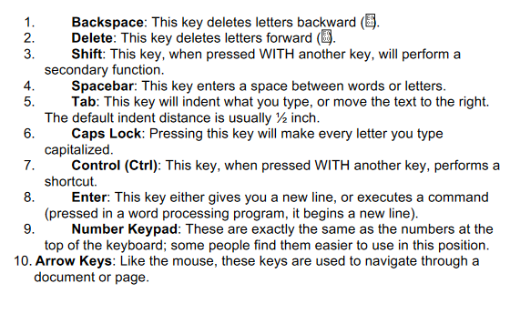

Activity:
Open Typing Club. Demo the first lesson together. Then encourage students to take the placement test. Students are able to create an account with this site. They can return to this lesson if they wish.
- Closing

- Briefly review what information we just covered in class (What is a computer? What are the Computer parts? Hardware vs. Software, Desk Top, Mouse Basics, Keyboard basics
- What questions do you have about what we just learned?
- Inform them of what information will be covered in the next workshop

- Typing Club: A free typing tutorial that covers the foundations of good typing practices. Great for beginners. https://www.typingclub.com/
- Typing attack: In this game you play a spaceship. Words are coming to attack your spaceship and you must type the words correctly in order to defeat them and defend yourself. This is a good game for people who want to increase their typing speed. https://www.typinggames.zone/typingattack

Desert Typing Racer: In this game , you are a drive. Words are other cars on the road. If you correctly type a word, then you won’t hit the car. Fast paced racing game that supports a learning typist. https://www.lifewire.com/free-typing-games-for-kids-and-adults-1357459

Keyboard Ninja: This game lets you practice specific topics in typing (like home row keys,) while playing a game. https://www.typing.com/student/game/keyboard-ninja
- Typing.Com Games: There are eight different typing games to choose from on this site. https://www.typing.com/student/games

Conclusion
- In the last 5 to 10 minutes of class, let students know they should consider wrapping up their games.
- Ask students if they have any questions about typing or keyboard use.
- Let students know what the topic will be for next week and direct them toward the resource sheet.

